Big Events of 2020 for the Labourers: The Oppression of the Bourgeoisie and the Resistance of the Proletariat
Originally posted by Gonghao 51 (Work Number 51): https://gonghao51.github.io/2021/01/01/laogongdashiji/
2020, doesn’t matter if you were in the factories, on the construction sites, inside the mines or speeding across the streets and alleys on an electric scooter, this was a particularly difficult year.
The built-up contradictions of capitalism suddenly intensified with the outbreak of the COVID pandemic. Global economic situations worsened, firms couldn’t get orders, and the greedy bosses didn’t want to bear the losses, transferring all the contradictions onto the workers, so we found out that there was more and more production, but less overtime work, wages and treatments didn’t get better, it got worse; many factories closed or had to cut down on workers, the army of unemployed rushed into the delivery industry, but an increase in the number reduces individual prices and intensified competitions, the capitalists behind these delivery platforms intensified their exploitation. The youth couldn’t earn money, pushed to the edge by mortgage, car and internet loans; our brothers and sisters above 40 couldn’t get a job anymore after getting fired and were forced home in order to eat.
This year, the most common thing 51 heard was: “These days jobs are hard to come by, take what you got, better than having no job.” Indeed, unemployment in the mouths of bourgeois economists is just a word, but for us workers, it means not being able to eat, kicked to the streets by landlords and not being able to pay for our children’s tuition. Everyone was afraid of losing their job, so we bore the exploitation if we could, as a result the number of collective actions fell—according to the statistics of the Chinese Workers’ Collective Actions Map (this website is an inconclusive collection, but because the scope of the data annually is the same, it’s good as a reference), in 2020 there were a total of 788 collective actions in China, a fall of 41.8% compared to the 1355 cases in 2019. The bourgeois government seized the opportunity, further trampling the rights and dignity of the labourer, opening more convenient gates for capitalist exploitation
2020 was a dark year, because the working class faced unprecedented oppression. 2020 was also a year bearing hope, class contradictions intensifies, 51 noticed that more colleagues were interested in politics and labour rights, because the days of work, marriage and kids that we were familiar with in the past, were becoming harder and harder to maintain. The seed of resistance has been planted; our working colleagues most seek another way!

Opression
Leishen Mountain Workers suppressed for defending their rights
From March 24th, the construction workers at Leishen Mountain posted many times on Weibo seeking help, saying that the 2500 Yuan/day of fees they were promised were taken by the agents, and the workers only got 500 Yuan/day. They were kept in quarantine for more than 40 days and were not allowed to leave, they couldn’t go out to work for money, and weren’t paid for the quarantine, the workers clashed with the security of the quarantine site.
A few days later, the workers defending their rights were forcefully demanded by the labour dispatching company and police to delete all relevant photos and videos from their phones, to write a promise, saying that they would not go to the government to raise any more demands. A few days later, the workers were escorted out of Hubei in batches.
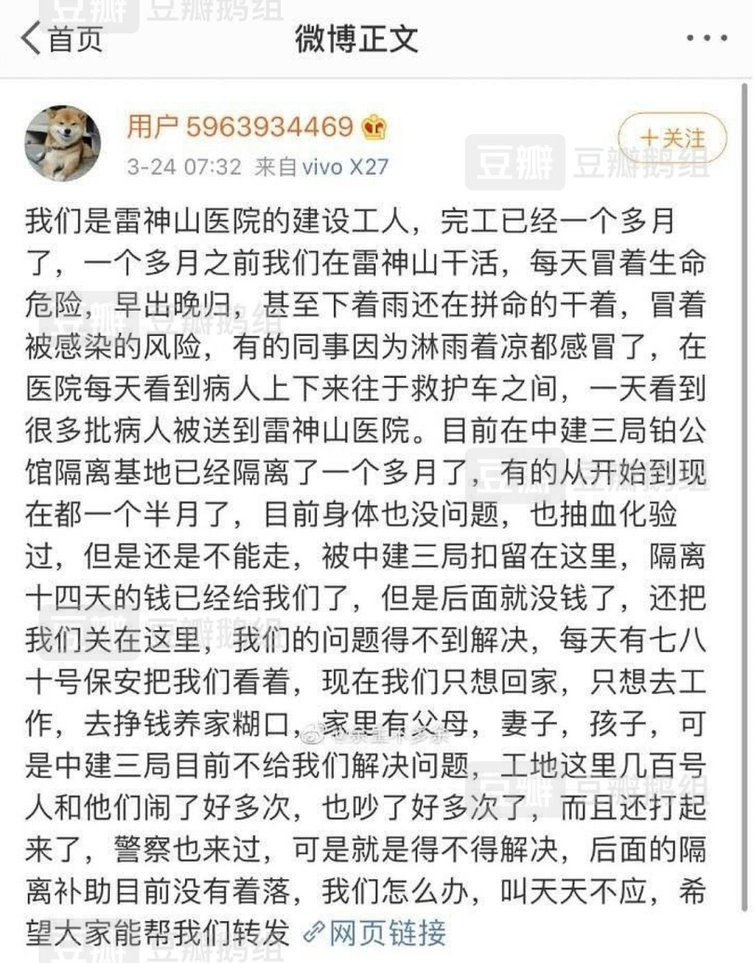
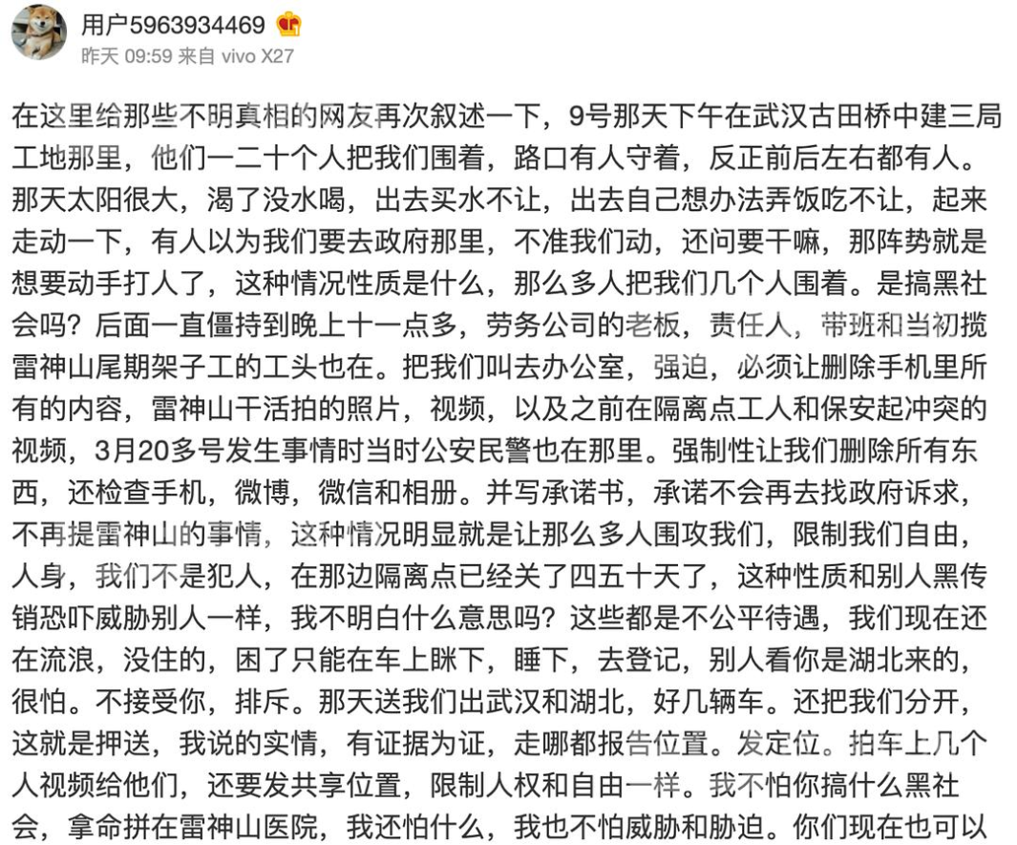
CCTV celebrated the speed of construction at Leishen Mountain and Huoshen Mountain, but the workers were nowhere to be seen in the reporting, not only that, their fees, which they risked their lives for, was taken away layer by layer, they wanted justice and got violent suppression. The construction heroes were like this, was there any dignity left for the broad masses of workers? The true faces of the reactionary government have nowhere to hide now.
Labour laws altered, a total regression in legal rights
Earlier this year, under the influence of the pandemic, the state was busy taking care of their precious capitalists, not only handing out big red packets like subsidies for stabilizing jobs and reduction in their share of the social security payments, they even allowed capitalists to reduce wages, they widened the scope for permitting the use of the damned aggregate working-hour system, from then on firms can make workers take working days off as they pleased; more unbelievably, even wage arrears were legalized!
In October, the supreme court in Guangdong Province made the verdict admitting Huawei’s “fighters’ contract” to be effective, reason being that the ex-employee Zeng Meng signed the contract willingly, without fraud or threats involved. However, every worker in Huawei is asked to sign this “fighters’ contract”, renouncing their paid annual holidays, if you’re determined to not sign, Huawei will use all sorts of methods to force you to leave.
In the same month, the Central Committee and the State Council issued the “Implementation Plan (2020-2025) for Comprehensive Pilot Reform in Shenzhen to Build the City into a Pilot Demonstration Zone for Socialism with Chinese Characteristics”, we noticed this: “A system for the management of special working hours that meets the needs of new technologies, new business forms, new industries and new modes shall be explored.” This means flexible working hours will be implemented en masse, wage deduction by capitalists was also formally legalized.
“Labour Law” was written in blood, it was brought to us with the lives of 87 female workers in Zhili toy factory. 27 years later, the bourgeoisie dared to shamelessly altered the law, rolling back the rights of the labourers, using the pandemic and the development of new industries as an excuse. No matter, they never cared about the lives and deaths of workers, writing laws were just to maintain the order of exploitation, if workers like us want total liberation, we’ll have to send all the old powers into their graves!
Delivery platforms squeeze their riders, the capitalist weaved a trap into the algorithms
September 2020, the “People” magazine’s in-depth reporting “Delivery Riders, Trapped in the System” caused strong repercussions. The article told us that our workmates in the delivery industry was having a harder and harder time. Relevant data suggested that in 2019, the average delivery time in all industries in China on average fell for 10 minutes compared to three years ago, every minute less is making the delivery riders break traffic laws more frantically, quite literally killing them. And the inhumane guiding system, dumbass “smile initiative” and insidious points ranking system, every single one is a deep cut on the bodies of our workmates, the faster they ride, the less they get paid, more than half of the riders cannot even cover the needs of their family with their income.
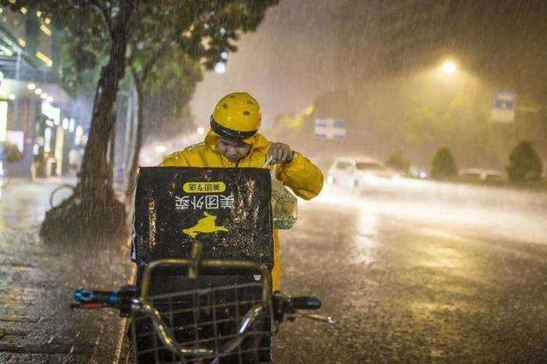
Some say that the riders are trapped by the algorithms, but who designed the algorithms and who does it serve? Saying that the riders are trapped in a high-tech system might as well be saying that they are trapped in a trap weaved by the capitalists.
Shishuo treated the workers like dogs, throwing their IDs straight on the ground
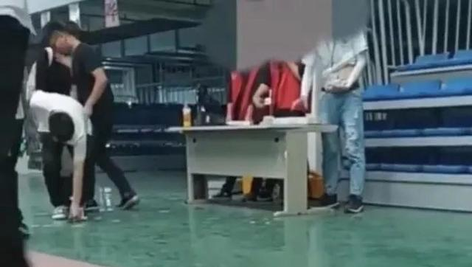
The person in red was the agent, the employees bent over to pick up their IDs
September, the video of agents “tossing IDs” in the Shishuo electronic factory in Kunshan, Jiangsu went viral on the internet, enraging internet users. In the video, labour agents were handing out IDs for new workers, for every name spoken, an ID was casually tossed to the ground, the workers had to bend their backs to pick it up, they might as well be treating dogs! Trampled and humiliated, this is the true portrayal of the workers under “socialism” with Chinese characteristics!
Mining accidents were common, our miner brothers could not rest easy in death
September 27th, the Songzao coal mine in Chongqing had an with Carbon Monoxide poisoning, killing 16 and injuring 42 miners;
December 4th, also in Chongqing, accident occurred in the Diaoshuidong coal mine, killing 23 miners
Two accidents in two months, the lives of 39 brothers were lost. Investigation suggested that both accidents occurred due to human errors, in the Songzao coal mine the belt on the coal cart was badly worn, a spontaneous combustion occurred which produced toxic fumes, whereas the accident in Diaoshuidong happened due to improper procedures of the company when dismantling the underground mining equipment.
What’s more infuriating was that the two coal mines were fined multiple times for going against safety protocols! And the higher-ups of the Songzao coal mine, the Chongqing Energy Investment Corporation, had three accidents from 2018 to 2020, a vehicle accident in the Fengchun coal mine, killing 7, a fire in a mine in Yanjing, resulted in the mine being closed down (no personnel casualties), an accident in the Lutang coal mine, kill 3. The lives of miners are not even worth the dark gold they dig up.
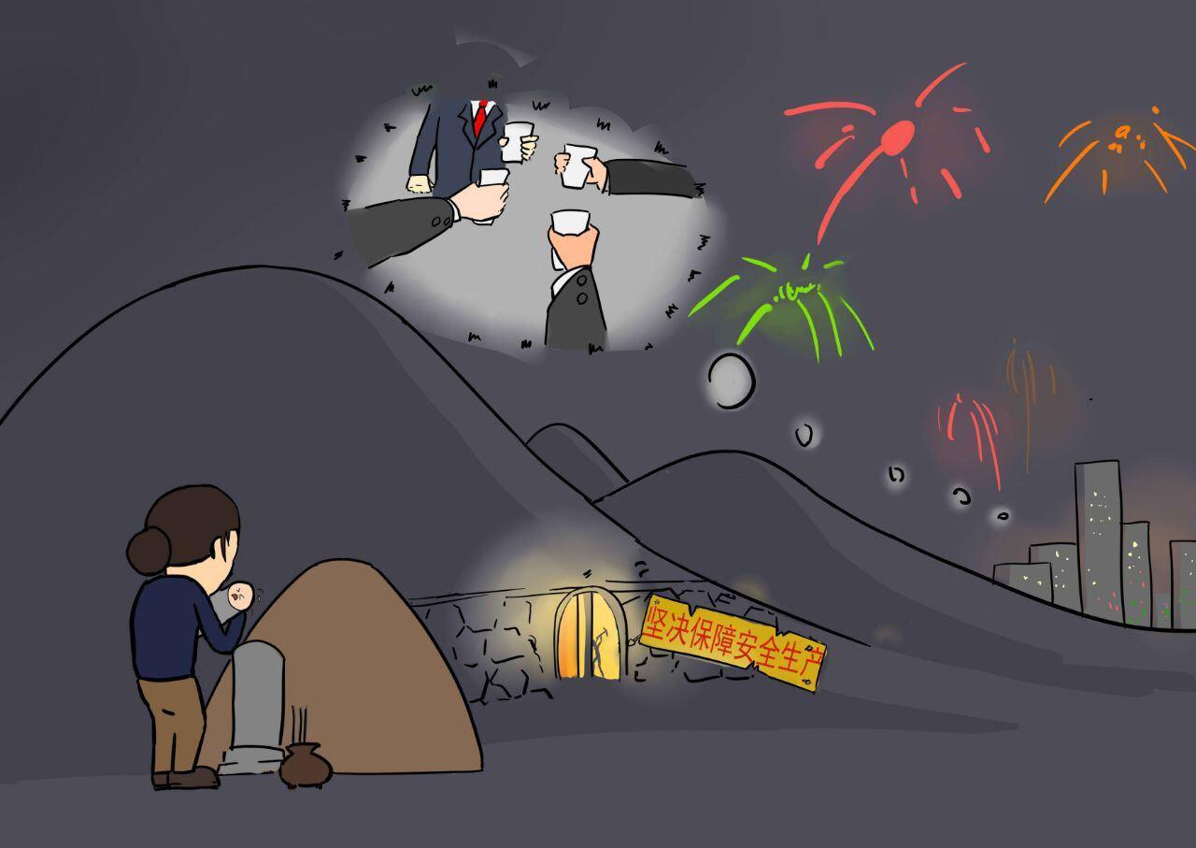
From the Xiangshui explosion to the accidents in 2020, It’s clear to us that: As long as the rotten capitalist system exist, the capitalists will always break protocols, will always disregard the lives of workers, no matter how many times they are fined. We put no more hopes in legal punishments or fines, only the working class truly masters the society can this fucked up situation be changed.

Resistance
Foxconn deduct wages, worker united in defense of their rights
When the pandemic was still rampant in February, Foxconn could not open, and forced the workers to take their annual leave, so as to avoid paying them their wages. This act was technically legal, but the workers in Foxconn didn’t roll with it, they step out of the legal boundaries and raised a complaint to the trade union. Under pressure from the workers, Foxconn amended their wage payment plans during the pandemic, and gave back the holidays from the 10th to the 17th!
The permanent workers achieved a victory, the dispatched workers were also on the offensive for their rights. Workers in different factories belonging to different agents collectively raised complaints to the Ministry of Labor, some gains were made, but the workers were divided by the strict standards for evidence.
The money involved was actually just one or two thousand, not much, but some workers on night shifts would not sleep so they could join the rally, workers on day shifts simply left their posts, even though they might be blacklisted or lose money. The worker leading them said: “I don’t care about the money, a little more work and I can earn that back, you gave the capitalists an inch and they take a mile, I just can’t swallow this!” They slapped those who said: “the workers won’t fight back if they are fed” hard in the face with their actions! The working class can view their dignity and future liberation more importantly that the concrete benefits at hand!
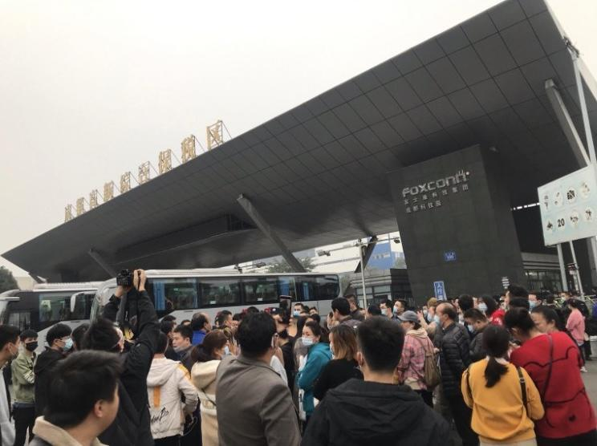
Working men went viral online, identity recognition of the oppressed class began to form
“Working men, working soul, working men are the better men”; “tired? That’s right, comfort is reserved for the rich”; “99% of suffering in life comes from work, but if you don’t work, 100% of suffering will come from poverty”……In November, the quotation of the working men became viral on the internet in just a few days, used to make fun of themselves by a lot of white-collar petty bourgeoisie.
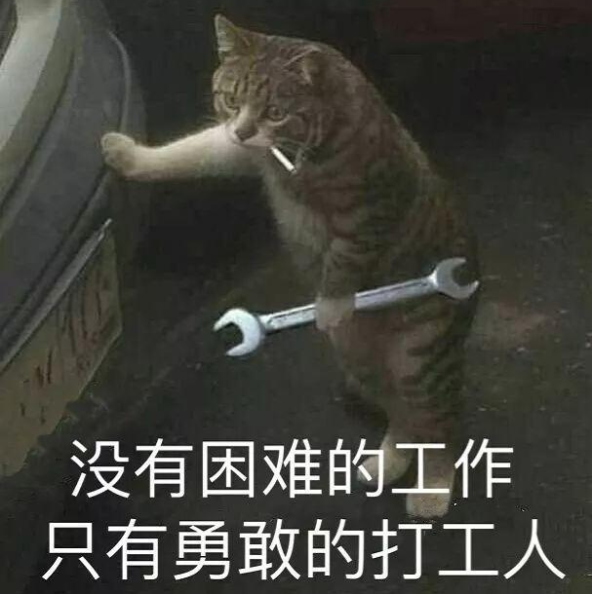
The lashes of the ruling class don’t just hit us workers, but also more and more on the petty bourgeoisie who has some skills and are exploited less. When 996 becomes the norm in offices, class solidification shatters their dreams of becoming the privileged, the white-collars are beginning to realise that they are not better than the migrant worker, they are just a tool for capitalist profits, a subject of exploitation.
We gladly see the collective conscious of an oppressed class forming in the petty bourgeoisie; and we, the working class, as the most exploited and oppressed class, is the most advanced and most revolutionary, we must bear the responsibility in leading the petty bourgeoisie in the overthrown of the old system.
The American people resist racial oppression; the heart of global imperialism is on fire
May, American black man Floyd was suffocated by the police by keeling on his neck, the already intensified class contradictions under the pandemic erupted. In almost every city in US imperialism, angry people took to the streets, opposing police tyranny and racial oppression. The protesters burnt down the police department, raised signs outside the Whitehouse even when faced with teargas; the poor stormed supermarkets to take back daily necessities, their slogan was “attack big businesses”, the proletariat began to break the legal boundaries of bourgeois private property, and were taking back what was rightfully theirs.
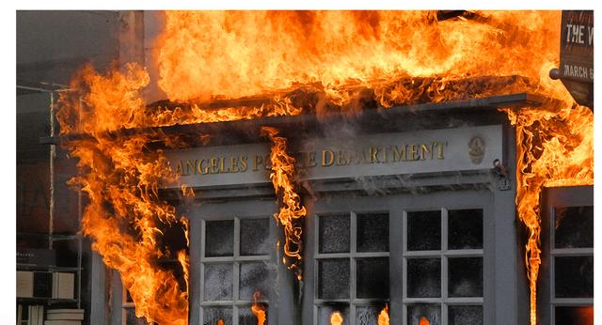
Police department burnt down by angry people
The bourgeois government carried out cold-blooded suppression of the movement, to maintain their rule, they torn off their disguises of “democracy and freedom”, and sent protesters to prison, shot rebelling crowds, issued a curfew to prevent people from taking to the streets, etc.
US imperialism is the heart of the global imperialist power, its rift with internal crisis, like a powder keg ready to explode. If the rule of US imperialist began to be shaken, is it too far from the collapse of the world capitalist system?
The poor would not be sheep awaiting slaughter, the labourers of the third world bravely rebelled
The first victims of COVID were the poor, especially the poor in the third world who have long been exploited and oppressed by imperialism. In Brazil, the virus run rampant in the ghettos; in Mexico, US imperialism forced workers in the export processing plants to work without protection, causing mass infections and deaths as a result; in India, Bangladesh and Vietnam, workers didn’t even have time to think about infection, because they might have starved to death before they got sick—due to quarantine measures and the reduction in orders from the first world, they lost their jobs. Struggles for better pandemic prevention plans, basic wage guaranties and against reopening the economy erupted in many places.
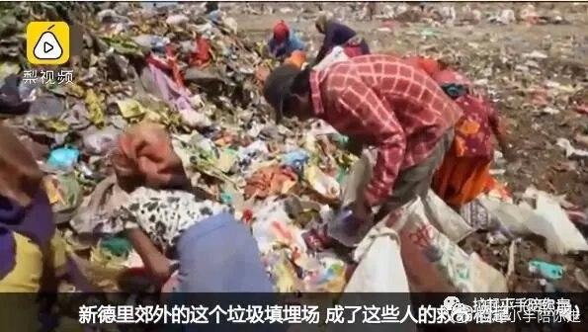
The poor without income resorting to picking up trash (New Delhi, India)
The bourgeoisie would not stop oppression for the pandemic, just like the Chinese “socialist” government, “pandemic” and “economic recession” became the best excuse for their reactionary policies, the people who can no longer bear the suffering, raised their fists in response. The Indonesian government feared that the imperial capital in its borders still wasn’t fed by the blood and sweat of its people, pushed out an anti-labour policy to “improve business environments”, lowering the minimum wage and layoff fees, changing the weekend to one day and abolishing the lifelong employment contract, as a result, millions protested and the trade unions organized a three-day general strike. India also had nationwide general strike, workers, peasants and students walked hand in hand to protest the reform that would give the pricing rights to monopoly firms at the expense of the farmers; they also protested the lockdown policies of the government, with 200 million participants, it was “the largest organized strike in human history”.
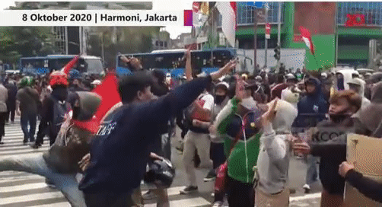
Indonesian protesters clashed with the police
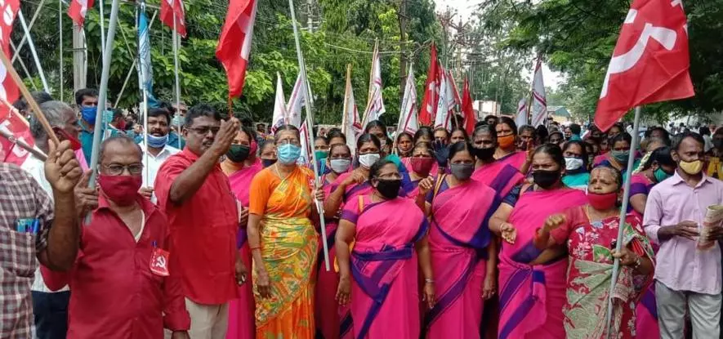
Indian weavers in Tamil Nadu
Pegatron dispatched workers struggle for their rebates, fearless in the face of police arrests
In late December, dispatched workers in Changshuo electronics factory under the Pegatron corporation carried out an explosive struggle.
The situation went like this, the agents promised the dispatched workers that in a certain time frame, if they worked for 60 days, they would get a high rebate of 10000 or 13500. But in December Changshuo’s order suddenly fell, the six-day working week became three. Not only did their wages suffered, their rebates would not be paid as there wouldn’t be enough work days, so the workers rallied at the gate of Changshuo demanding an explanation. The local government sent out riot police to suppress and arrested the workers at the front, some were even injured! This did not scare off the workers, most refused to sign the ridiculous proposals Changshuo gave out after the first march. With perseverance, rebate was raised from 6000 to 9000; finally the government stepped in, offering 90% of what the agents promised.
Compared to what happened in Shenzhen at the beginning of the year, the workers were more united, workers from dozens of different agent entered the same group and proposed the same demands, not scattered in different groups by different agents, and so they got the same results, the situation where the workers from one agent got the money while the others didn’t did not happen, the scheme by capitalists to divide the worker had bankrupt! Also, amongst the crowd, many female workers walked at the front and were taken by the police, their heroism impressed even the men---our working sisters will not be the submissive wives and diligent mothers promoted by the mainstream media, and will certainly not be the low-paid, obeying, perfect subject of exploitation by the capitalist, they are a force to be reckon with in the fight for workers’ liberation!
The struggle in Changshuo had just ended, on the other side, another branch of Pegatron, Shishuo in Kunshan (yes, the one that treated their workers like dogs), their dispatched workers were also on the move. The company heard that Changshuo’s workers got 90% of their rebate, and shamelessly decleared that they would also only pay 90%! The workers are still struggling with the factory and the police, let us wish them a good luck, and hope they would get their rebates in full!
In recent years, Apple’s commission factories began to replace permanent workers with dispatched workers, they lure them in with high wages or rebates when they are busy, fire them in two or three months when the time’s up. This way, not only is it flexible for them, they can avoid paying social security and other welfares. The bonus sounds great when the workers are hired, but when it’s time to pay up, the agents and the factory will use every method to delay it, without some struggle the rebates will usually not be paid. Pegatron is a commission of Apple, November a struggle also erupted in the Foxconn factory in Chengdu, reason was also rebate payment. Struggle by the dispatched workers had become a new trend in the worker’s movement in recent years, workers have seen clearly that the so-called agents are but puppets of capitalists, the factories didn’t give the money to the agents, of course they won’t be able to pay, so we have to target the factories for our money.
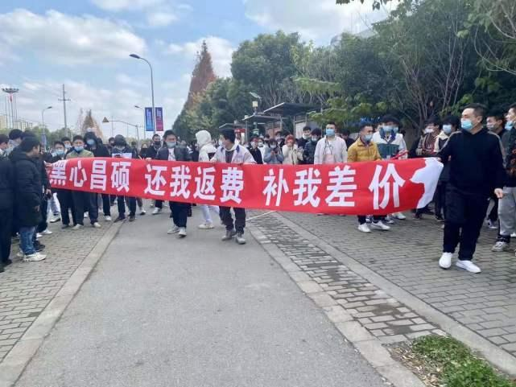

Conclusion
One article is not enough to describe the blood, sweat, tears and suffering of the workers, it’s also not enough to document all the sparks of rebellion. 2020 is the year where bourgeois oppression advances, it’s also the year where class antagonisms intensifies and class struggle grows. “Hard work creates wealth”, “fair competition” and “the government serves the people” all these lies are bankrupt, hatred for the capitalists, value is from labour has become our shared value and pursuit.
Workers, readers, in this New Year, let us continue our fight with the faith in victory!

Bourgeoisie be damned, used the virus for their plans
Bitter is the working men, working hard while the food is blend
Madness of capitalism, marks its doom
Class opposition, leads to struggle for liberation
