Morocco accused of prison torture in Amnesty report

'Roast chicken' and 'Airplane' just two of the tortures used on dissidents in jails belying liberal image of tourist-friendly holiday destination
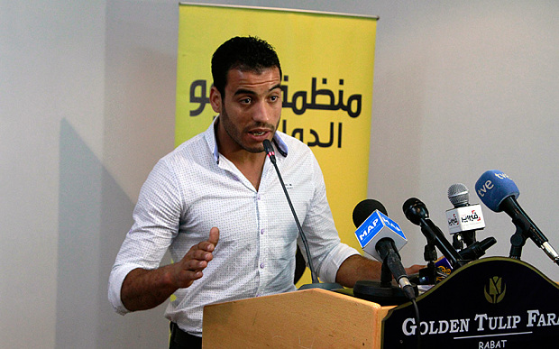
Abderrazak Jkaou describes to reporters how he was tortured and beaten by police for demonstrating, in Rabat Photo: Paul Schemm/AP


By Richard Spencer, Middle East Editor, The Telegraph [U.K.]

3:22PM BST 19 May 2015

Moroccan prisons use the same methods of torture as those in other Arab countries, despite its reputation as a relatively liberal tourist haven, Amnesty International says in a report on Tuesday.
Students, left-wing or Islamist political activists, supporters of autonomy for the territory of Western Sahara, as well as those accused of terrorism and other crimes, are subjected to a wide range of physical, sexual and mental abuse, the report found.
Among the preferred tortures used to extract confessions was the “roast chicken” - suspending the prisoner from an iron bar by the wrists and knees, so called supposedly because of its similarity to a roasting spit.
Others included beatings, stress positions, asphyxiation, simulated drowning, and threats of rape and other forms of sexual violence. In rarer cases, there was actual rape, using objects such as bottles, or rape attempts.
One student activist, Mohamed Ghallod, alleged that police had stripped him, raped him with a baton, urinated into his mouth, and hung him in the “roast chicken” position and also the “airplane position” widely used in the Middle East, where the prisoner is suspended with his arms behind him.
Another man, Mohamed Ali Saidi, 27, was also threatened with rape, with a fizzy drink bottle that was brought in and shown to him, and then beaten, he said.
“They whipped the soles of my feet with ropes, while I was suspended in the roast chicken position, and they also dipped our feet in iced water,” he said. “While I was suspended in the roast chicken position, they put a towel in my mouth and choked me by pouring water up my nose.
“Then they poured urine. Then they took my clothes off except my underwear, and whipped me on the thighs with belts.”
Amnesty interviewed 173 people for the report, including men, women and children. They also outlined a new practice whereby those who complained about what had happened to them were prosecuted for “false reporting” and “slander”.
The courts can impose a prison sentence of up to five years for slander, as well as demanded substantial compensation payments.
“Morocco’s leaders portray the image of a liberal, human rights-friendly country,” Salil Shetty, Amnesty’s secretary-general, said. “But as long as the threat of torture hangs over detention and dissent that image will just be a mirage."
Tourism has been a boom industry in Morocco, based partly on the perception that it is relatively open and liberal.
However, last year, Ray Cole, 69, a British tourist, complained about prison conditions after being arrested on suspicion of "homosexual acts", which are illegal. "I've seen things I never knew existed," he said after his release. "It's not a prison, it's a concentration camp."
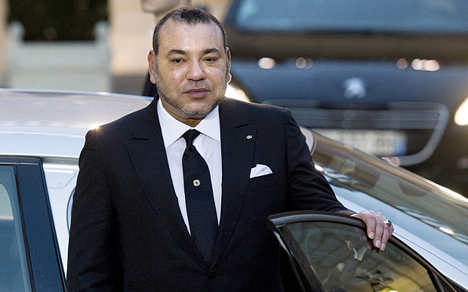Morocco's King Mohammed VI (AFP)
King Mohammed VI has liberalised the political system in recent years, and it now has an elected parliament and government, currently moderate Islamist-led. However, the monarchy still retains substantial power.
The government issued an extensive, 50-page rebuttal of the Amnesty report, published alongside it.
It attacks Amnesty’s methodology and accuses it of bias, saying that Morocco’s progress on human rights issues is internationally recognised.
“The Moroccan authorities believe that the primary purpose of this report is to undermine the Kingdom,” it says. “Despite several advances mentioned by way of introduction, most achievements and concrete measures are effectively ignored.”

From: http://www.telegraph.co.uk/news/worldnews/africaandindianocean/morocco/11615136/Morocco-accused-of-prison-torture-in-Amnesty-report.html

